Link to Ion Video link this from ion pendent and again this same page for the Ion Mask

https://youtu.be/eWSY1tnA05c
Ion Information
We had only one day prepared for Expo we are upgrading our old flyers. The Ionizers have been upgraded to today’s standards. We are upgrading the flyers etc.

Specifications: for the Ion Pendent are nearly the same for the Ion mask
Material: PC Casing, Stainless Steel Chain
Input Voltage: DC 5V
Input Power: 0.1W
Frequency: 2KHZ
Battery: 3.7V 200mAh
Power Supply: USB
Control Method: Button
Size: appr.55x60x20mm/2.16x2.36x 0.79 inch
Weight: 30g
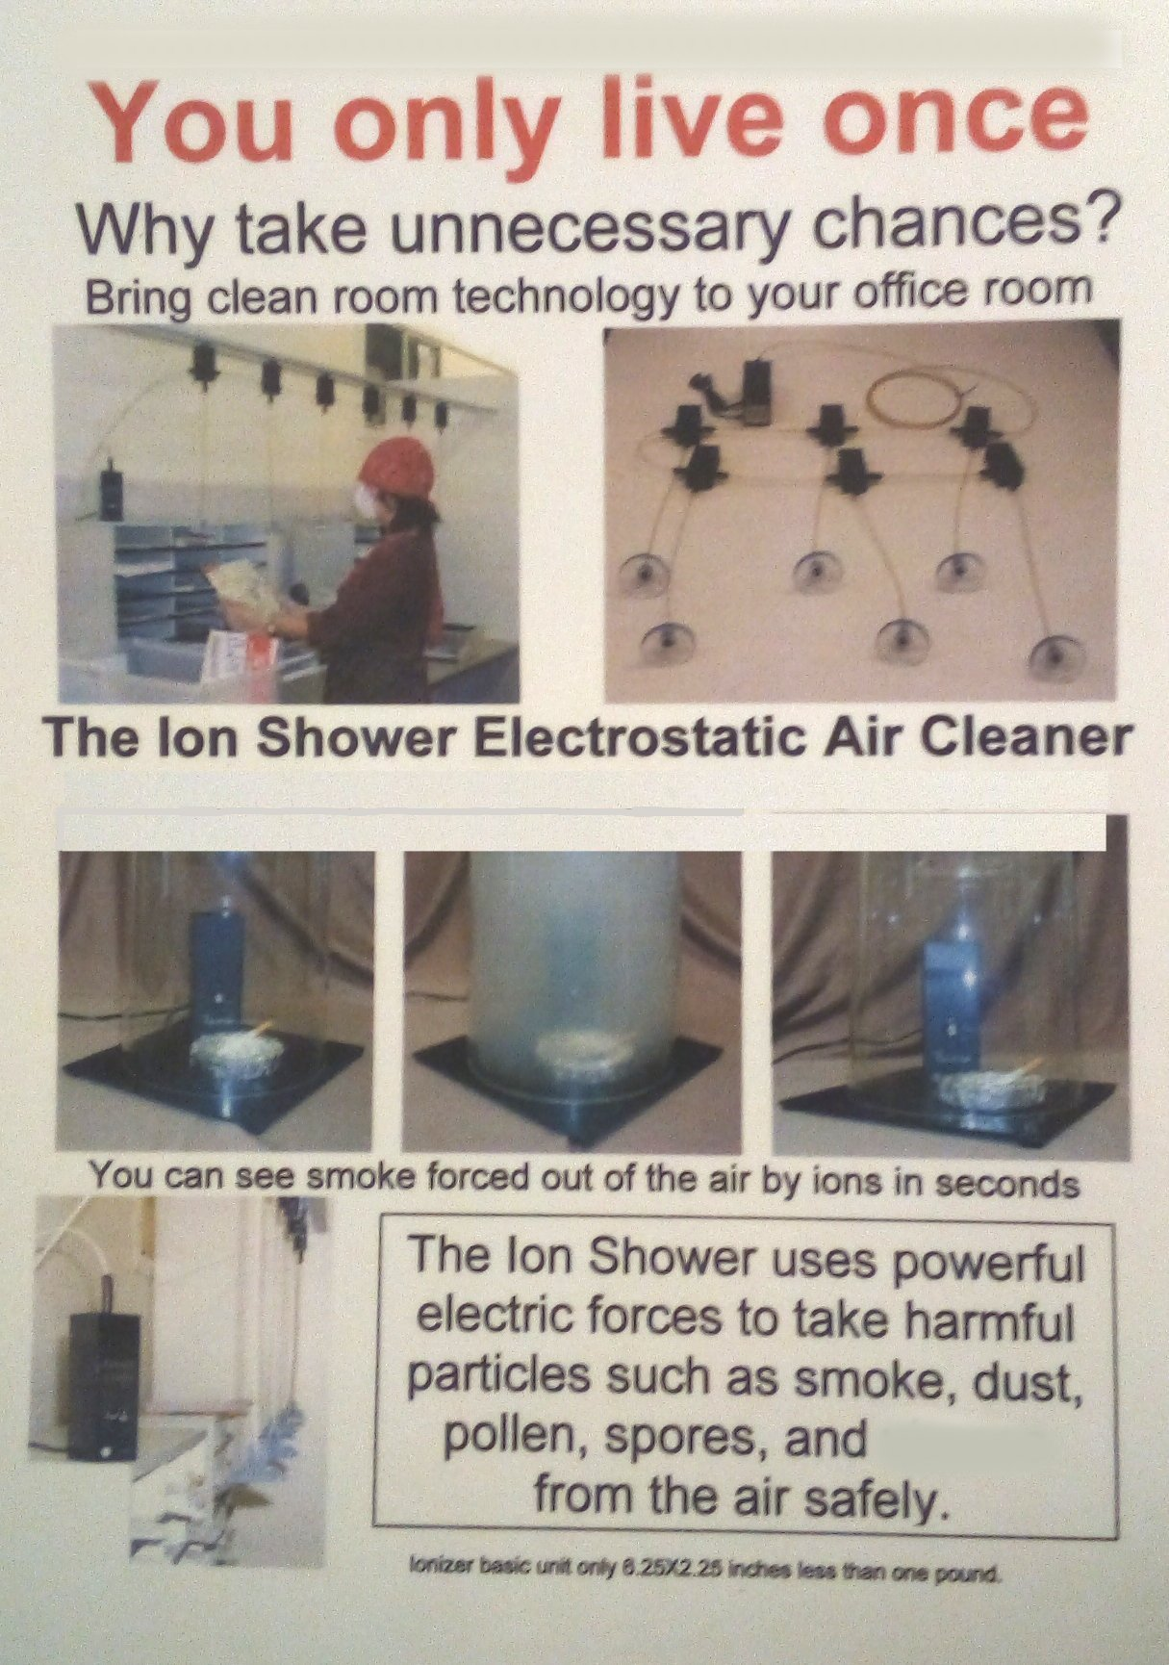
Package Includes:
1 Piece Air Purifier
1 Piece USB Cable

Our Ion Air Cleaner business company was born in the seventy's. I used the technology used to detect Ions to build the Aura Camera. Then I used the aura camera technology and created MindVR a Virtual Reality content provider. Please Take a look at www.MindVR.com If you have or know someone who does have a 3DVR viewer you can see Cardi-B, President Clinton, and many others in our virtual world it is like you are standing right next to them. Looks so real it feels like you can reach out and touch them now 40 years later because of the coved virus and I am back in the clean air business.

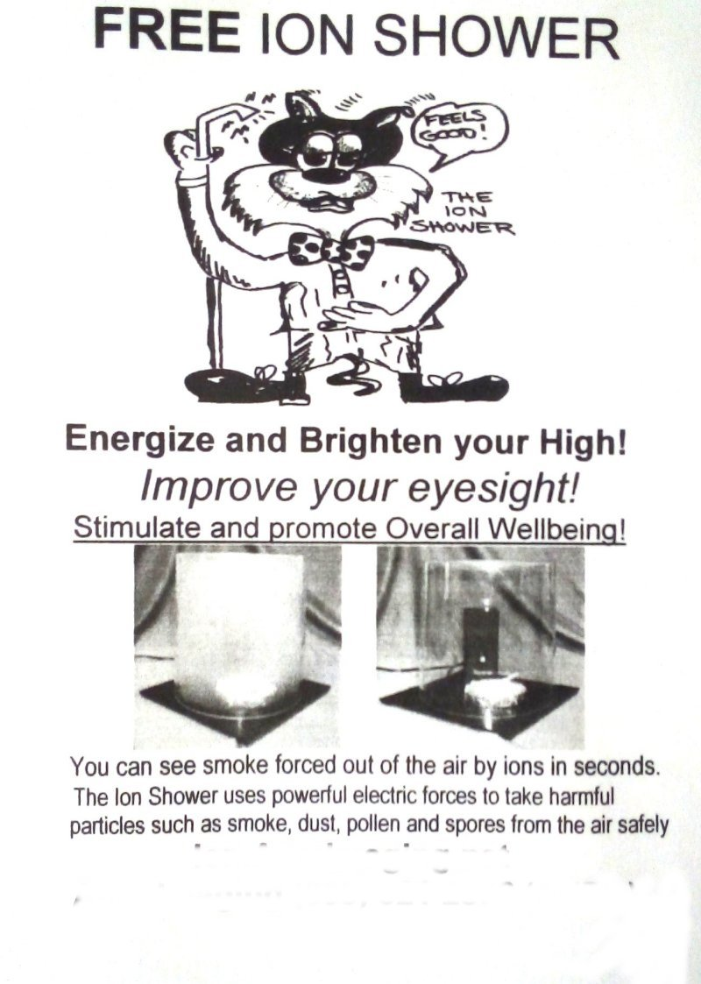

One of the subtle effects of high powered negative Ions is similar to breathing pure Oxygen. The Ions seem to relax the individual and if the person is over 40 and not warring glasses there eyesight improves. Most could read two more lined down on a eye chart.

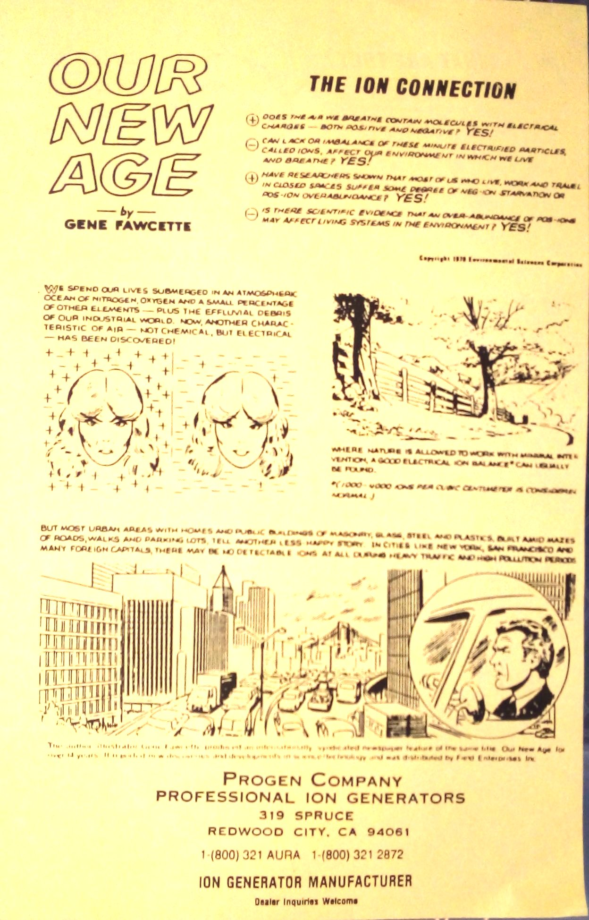

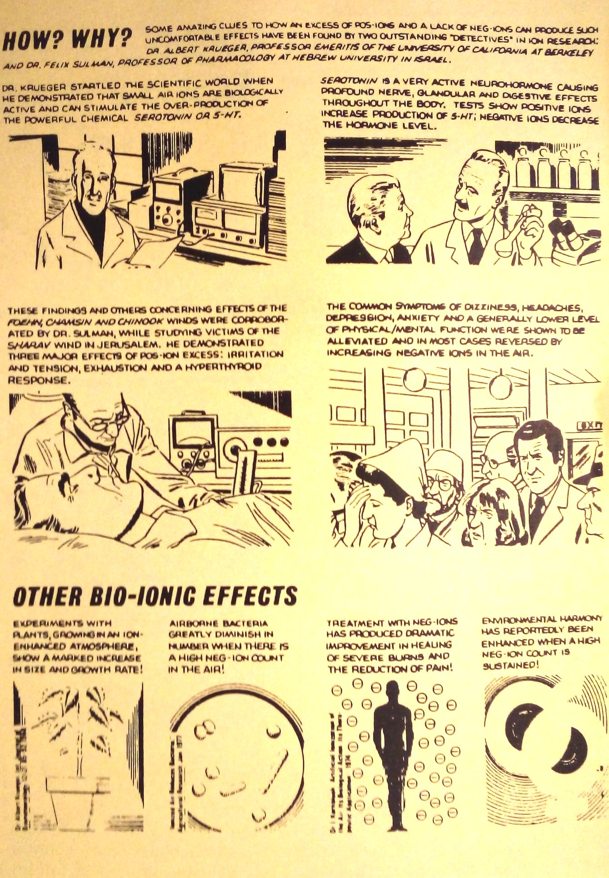

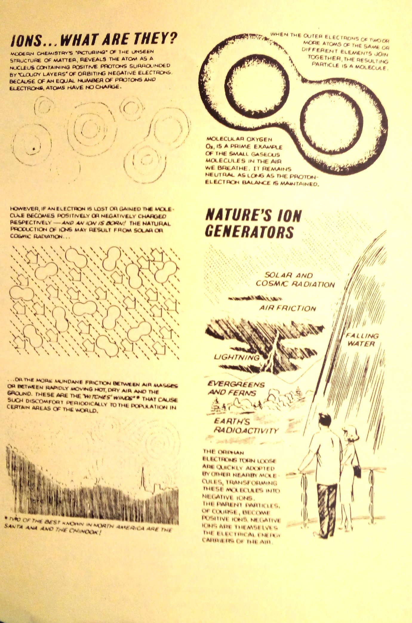

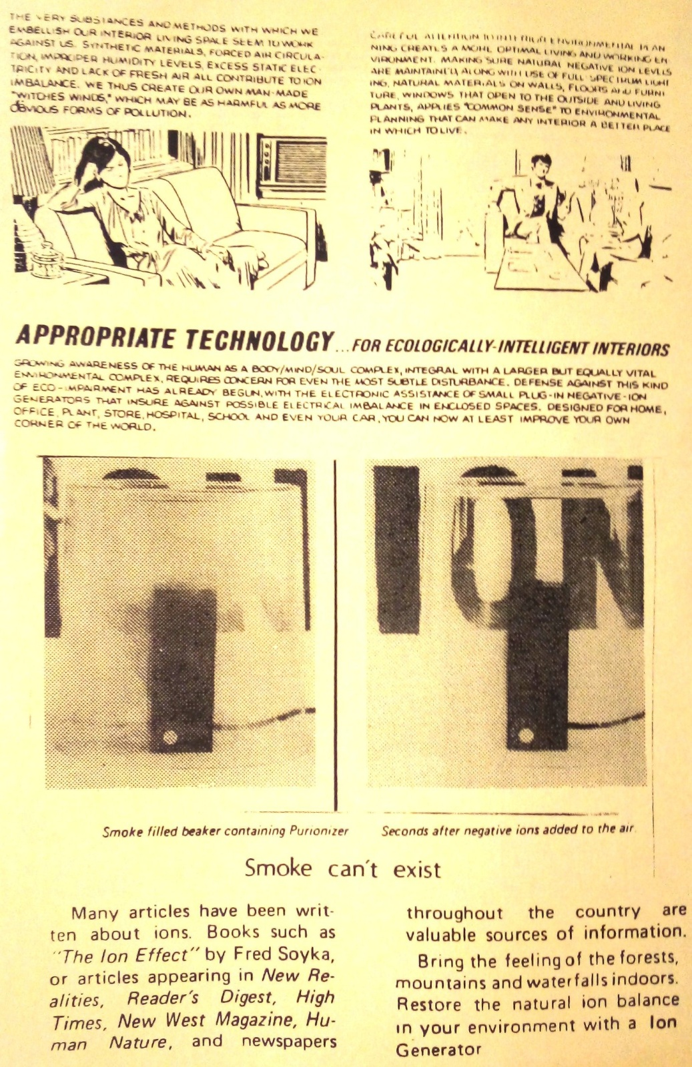

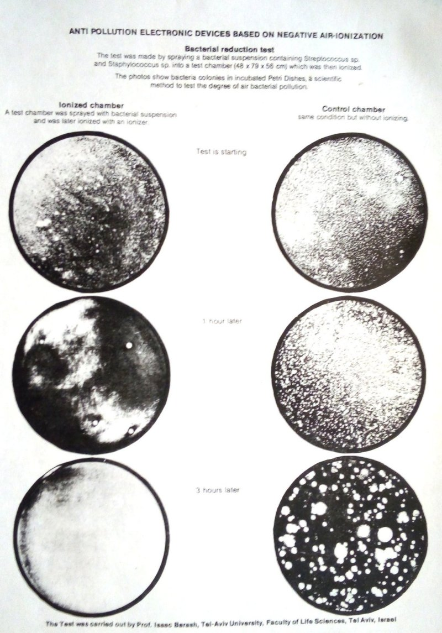

Shows the results of the Israel tel-aviv test. Israel was the first country to build commercial ionizers.

Negative Ions not only will take pollutes out of the air they produce a very bad environment for them the book Ion controversy by PhD. Charles Wallach. Charles stayed at my house when he would come to the SF bay area. He consulted for my company Progen Company it stands for Professional Ion Generators. Dr. Wallach worked for the military and helped the navy install ion generators in our sublimes.

The ion controversy: A scientific appraisal: Charles Wallach ...
www.amazon.com › ion-controversy-scientific-appraisal

The ion controversy: A scientific appraisal [Charles Wallach] on Amazon.com. *FREE* shipping on qualifying offers.

Updating the ION controversy: Charles Wallach: Amazon.com ...
www.amazon.com › Updating-ION-controversy-Charles-Wallach

Updating the ION controversy [Charles Wallach] on Amazon.com. *FREE* shipping on qualifying offers.

controversy ion - AbeBooks
www.abebooks.com › book-search › title › controversy-ion

The ion controversy : a scientific appraisal by Wallach, Charles and a great selection of related books, art and collectibles available now at AbeBooks.com.

The ion controversy by Charles Wallach at AbeBooks.co.uk - ISBN 10: 0959229701 - ISBN 13: 9780959229707 - Belle Lumiere - 1983.

