Link to Ion Video

<https://youtu.be/eWSY1tnA05c>

We had only one day prepared for Exop we are upgrading our 30 year old flyers. The Ionizers have been upgraded to day’s standards.



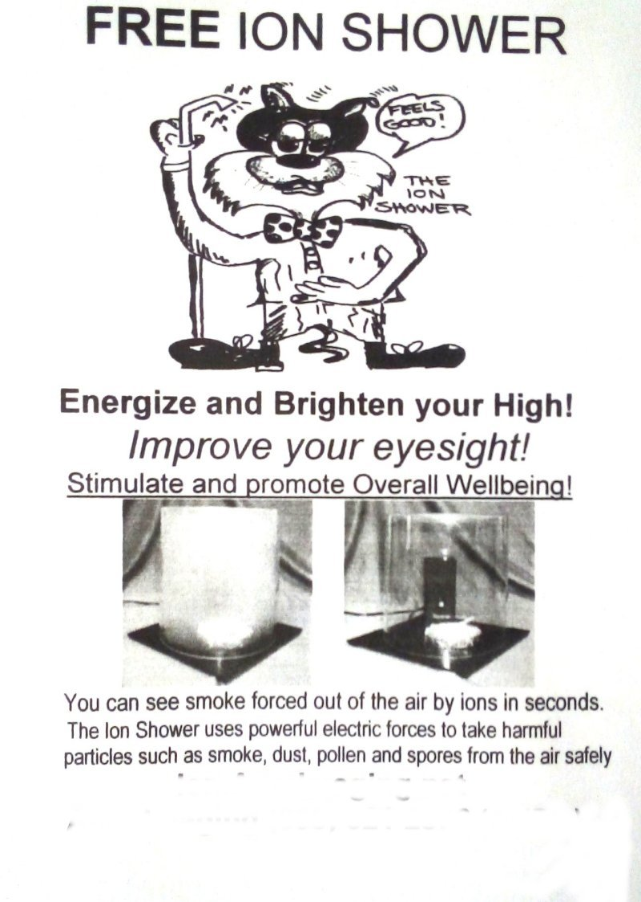

One of the subtle effects of high powered negative Ions is similar to breathing pure Oxygen. The Ions seem to relax the individual and if the person is over 40 and not warring glasses there eyesight improves. Most could read two more lined down on a eye chart.

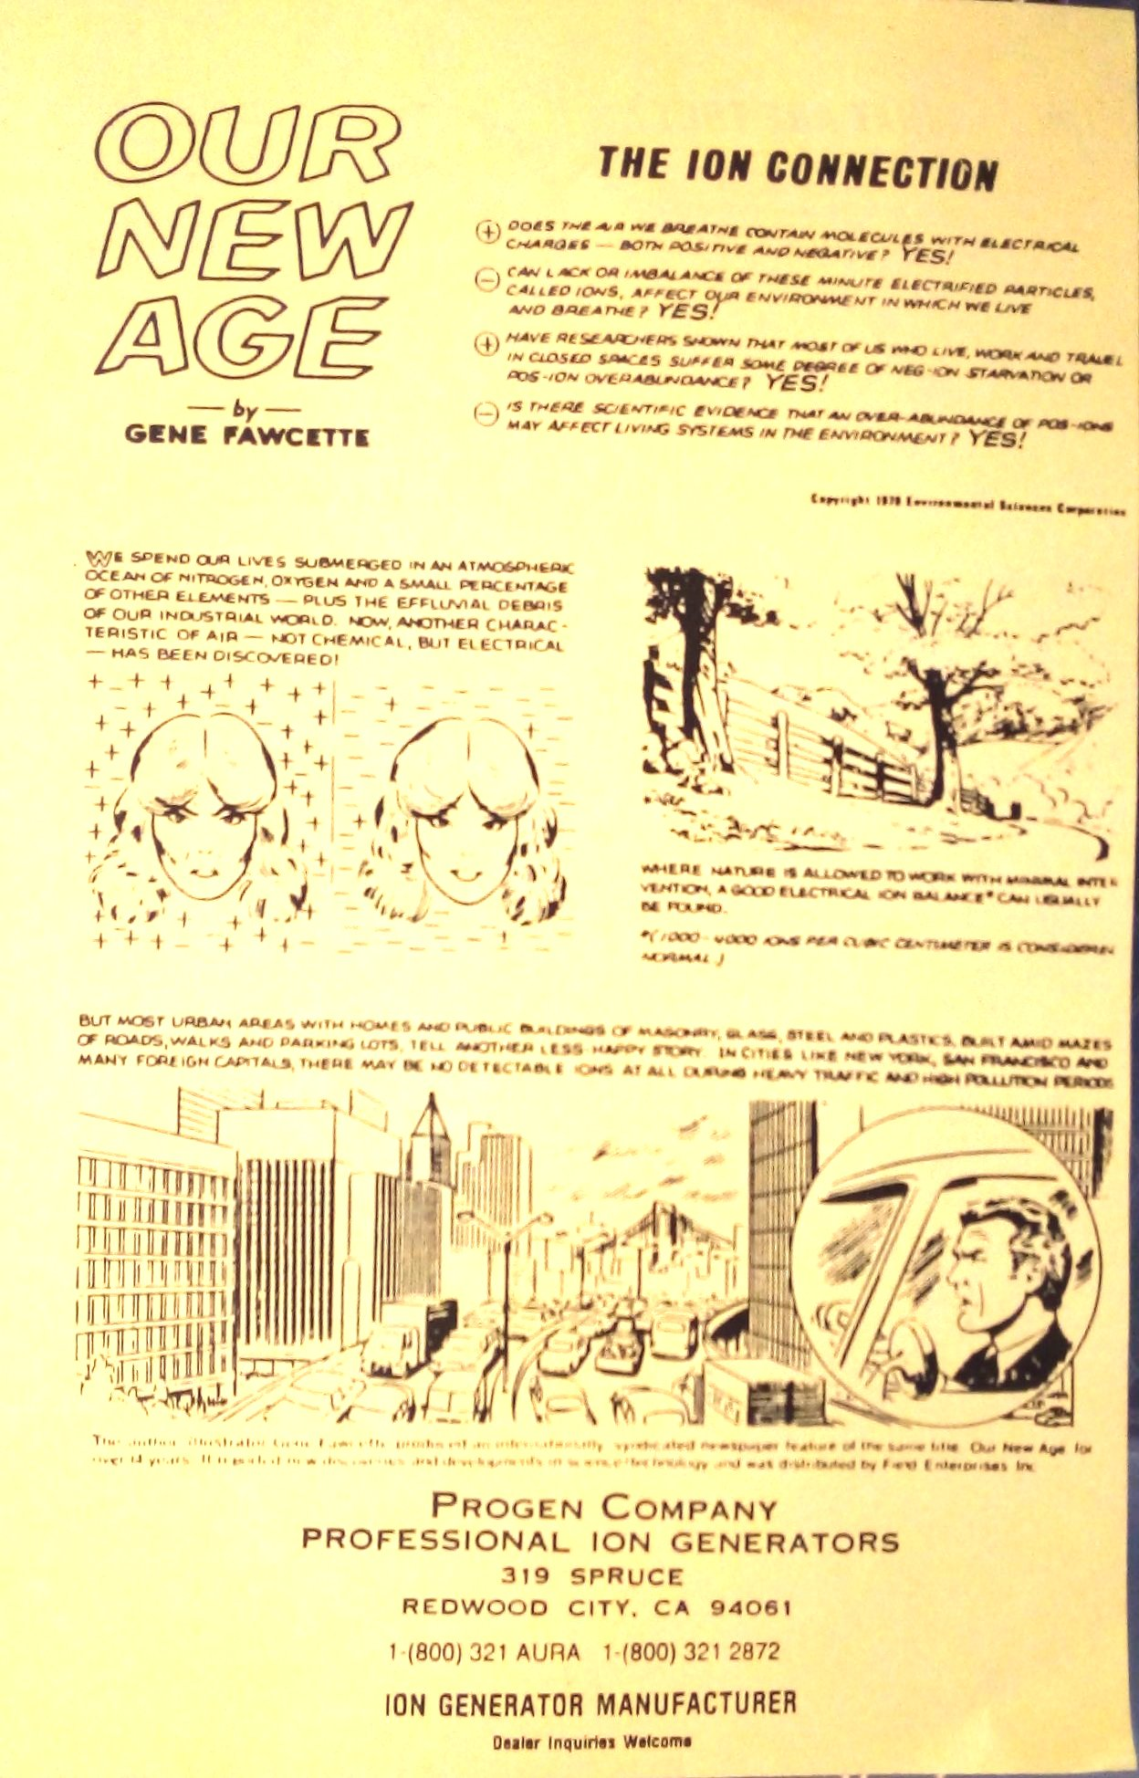

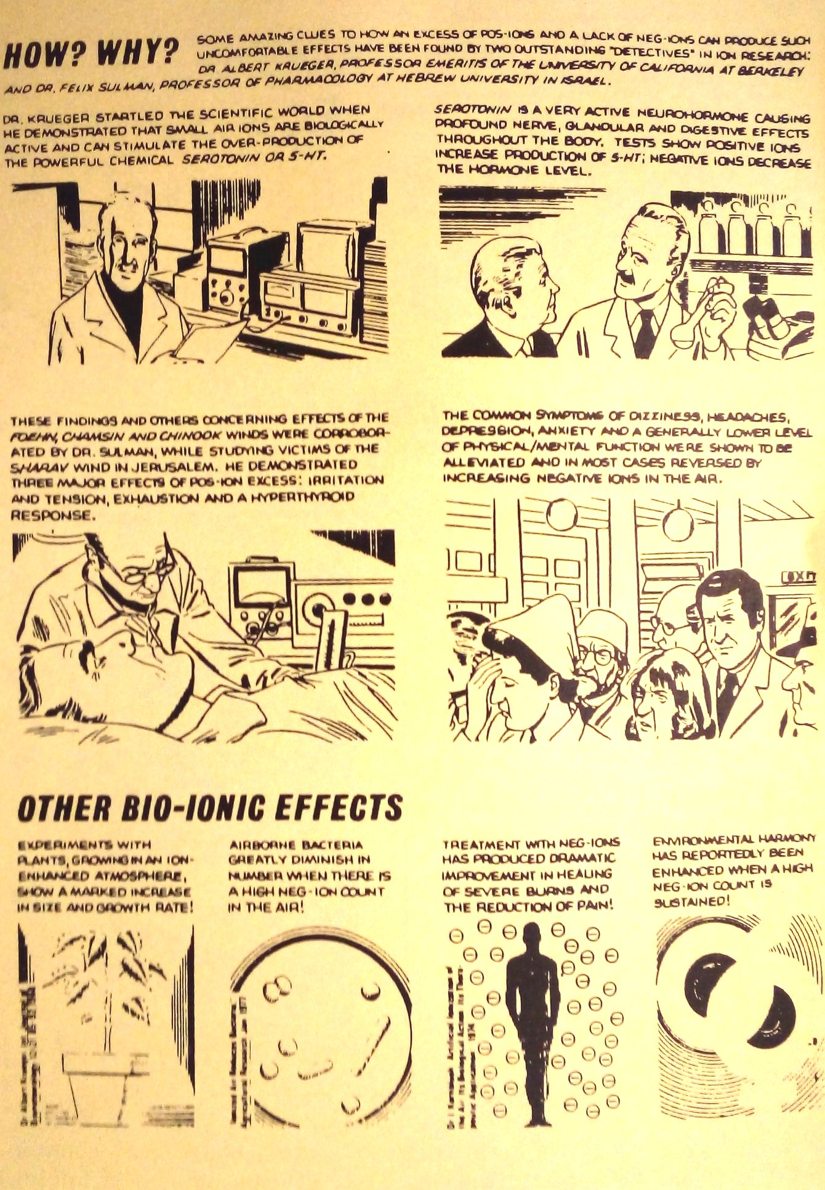

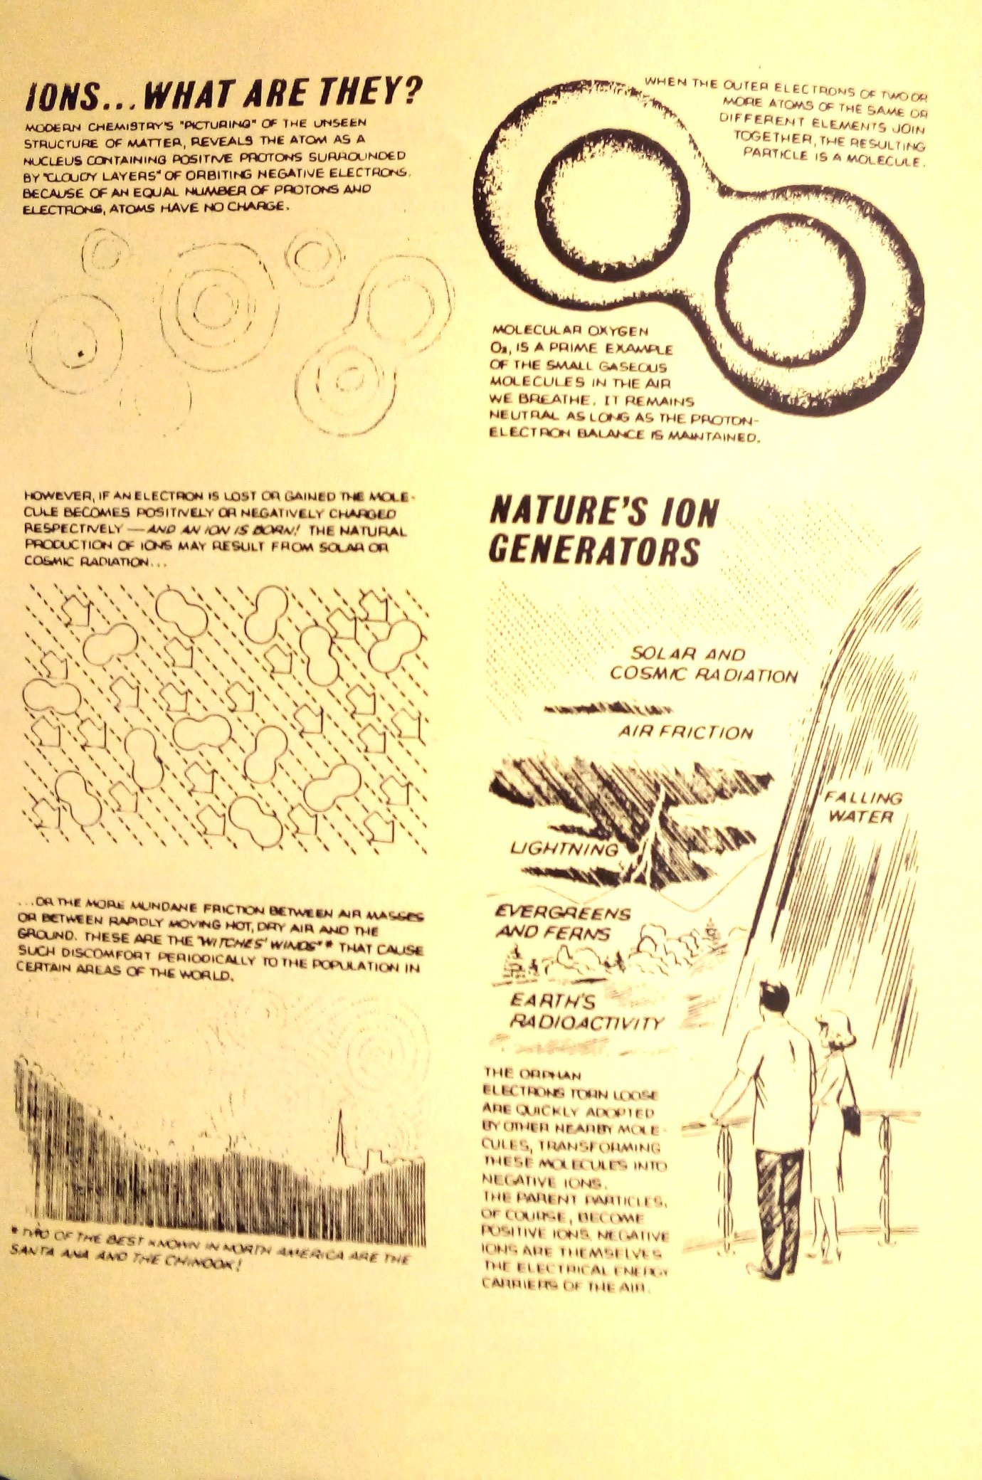

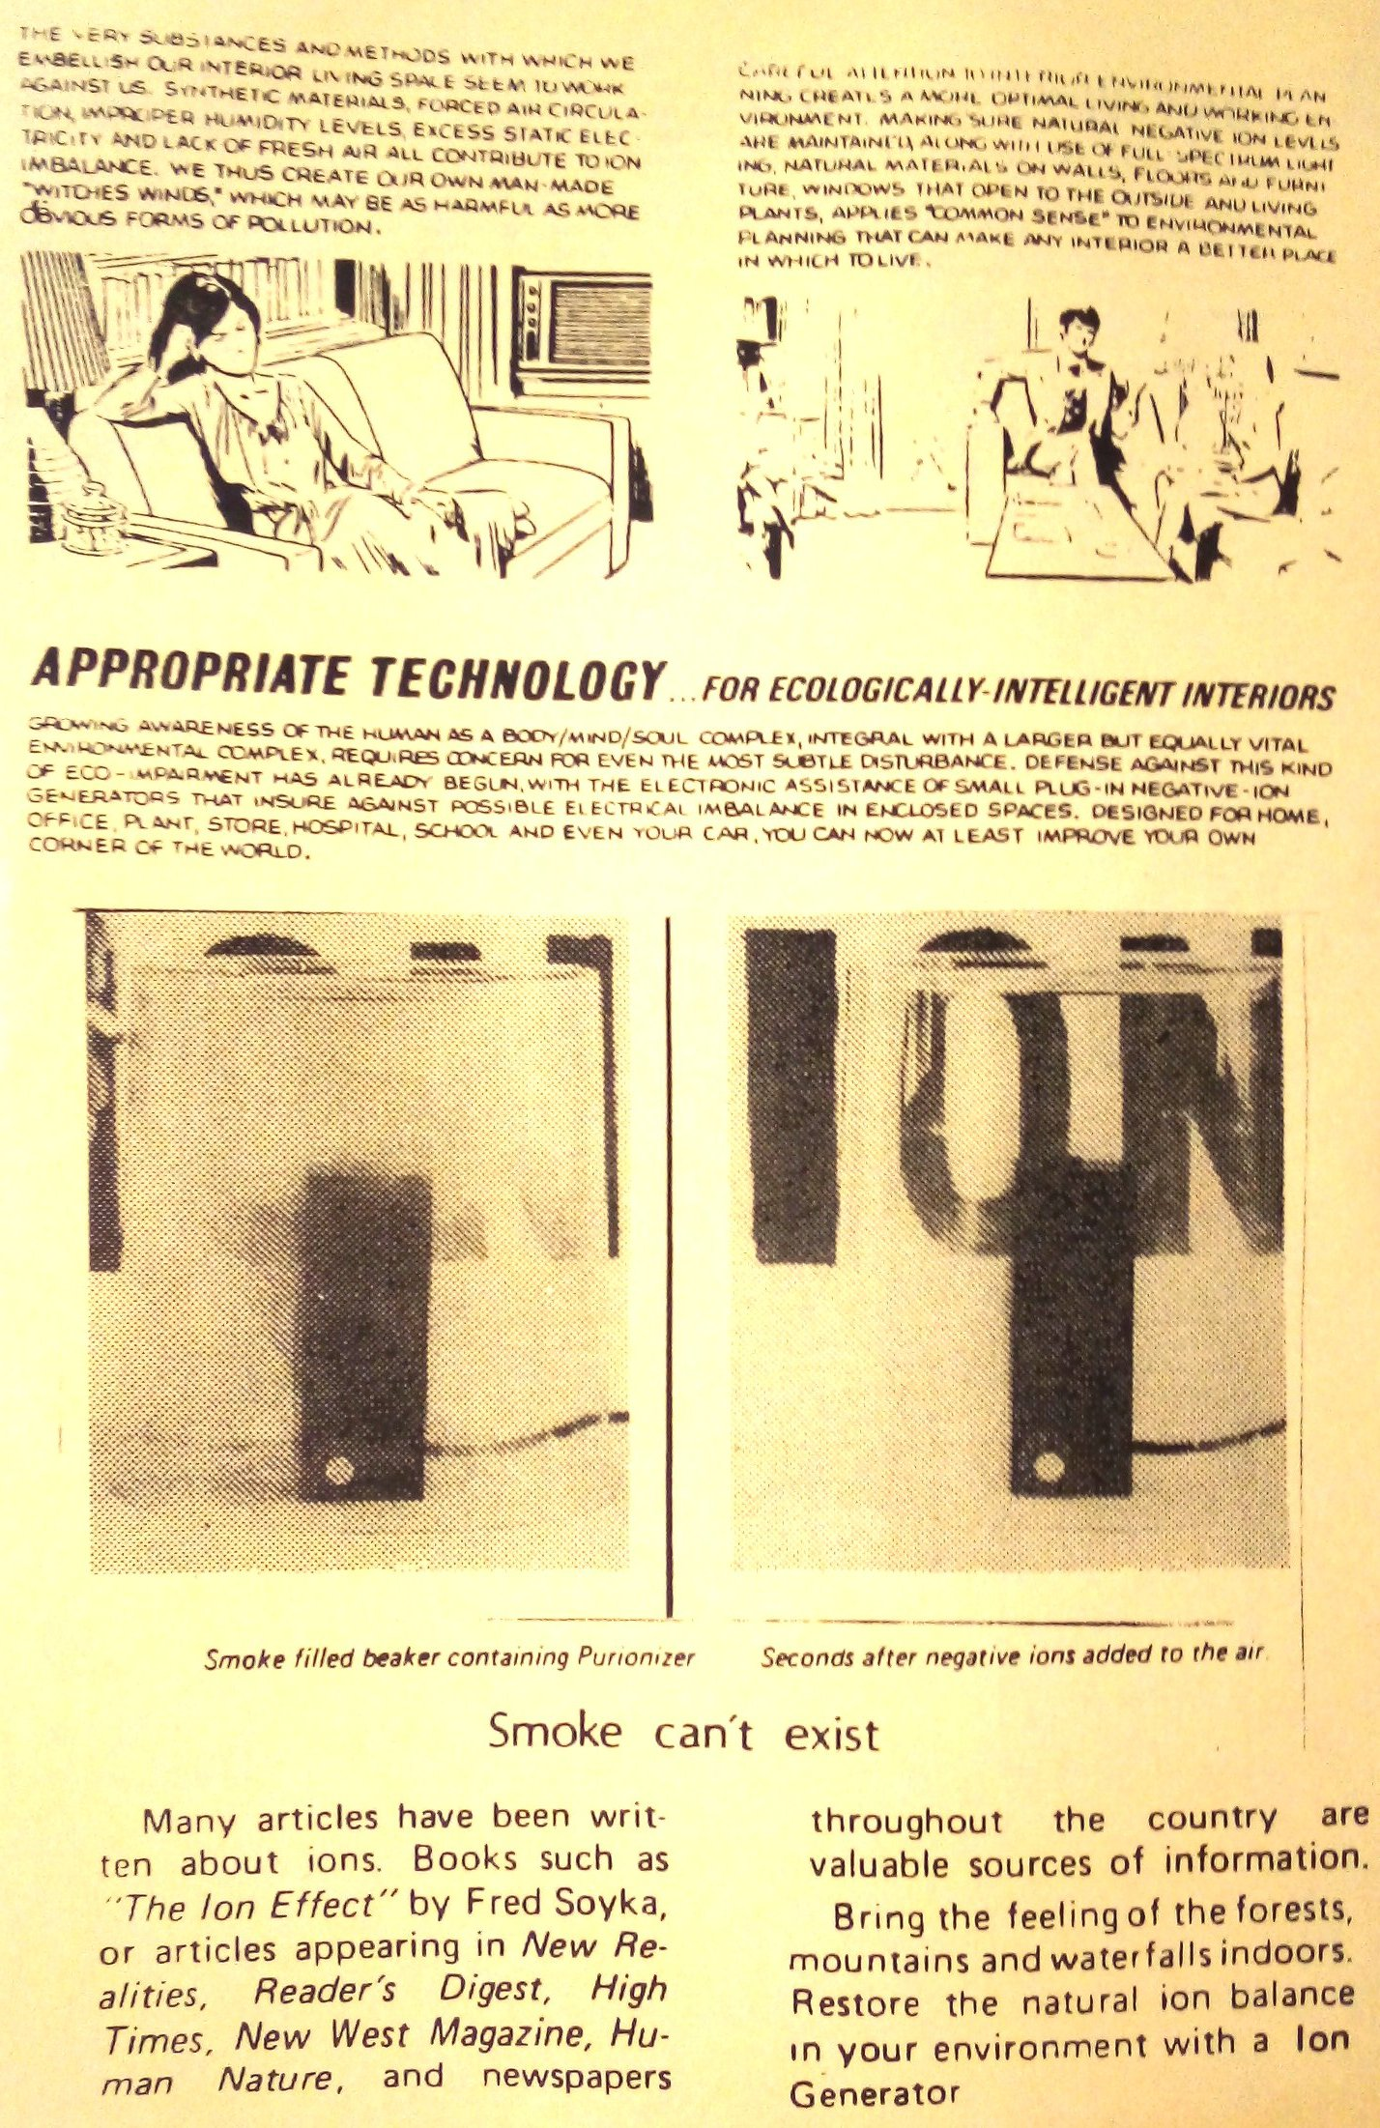

Negative Ions not only will take pollutes out of the air they produce a very bad environment for them the book Ion controversy by PhD. Charles Wallach. Charles stayed at my house when he would come to the SF bay area. He consulted for my company Progen Company it stands for Professional Ion Generators. Dr. Wallach worked for the military and helped the navy install ion generators in our sublimes.

### [The ion controversy: A scientific appraisal: Charles Wallach ...](https://www.amazon.com/ion-controversy-scientific-appraisal/dp/0959229701)

[www.amazon.com › ion-controversy-scientific-appraisal](https://www.amazon.com/ion-controversy-scientific-appraisal/dp/0959229701)

The **ion controversy**: A scientific appraisal [Charles Wallach] on Amazon.com. *FREE* shipping on qualifying offers.

### [Updating the ION controversy: Charles Wallach: Amazon.com ...](https://www.amazon.com/Updating-ION-controversy-Charles-Wallach/dp/B0006XAX94)

[www.amazon.com › Updating-ION-controversy-Charles-Wallach](https://www.amazon.com/Updating-ION-controversy-Charles-Wallach/dp/B0006XAX94)

Updating the **ION controversy** [Charles Wallach] on Amazon.com. *FREE* shipping on qualifying offers.

### [controversy ion - AbeBooks](https://www.abebooks.com/book-search/title/controversy-ion/)

[www.abebooks.com › book-search › title › controversy-ion](https://www.abebooks.com/book-search/title/controversy-ion/)

The **ion controversy** : a scientific appraisal by Wallach, Charles and a great selection of related **books**, art and collectibles available now at AbeBooks.com.

The **ion controversy** by Charles Wallach at AbeBooks.co.uk - ISBN 10: 0959229701 - ISBN 13: 9780959229707 - Belle Lumiere - 1983.