The life you save may be your own




Mind VR 3D VR, T shirts,
Cinematic VR Films, Music Videos,
Smile Mask covers. MindVR
MindVR.com 650 212 6709
319 Spruce St Redwood city Ca 94063
T shirt or mask Care and Maintenance
Washing:
Before washing turn inside out.
Wash gently by hand.
Wash separately from other clothing.
Use color-safe soap or detergent.
Do not use bleach.
Remove promptly, as colors may bleed if left wet too long.
To prevent color bleeding dry immediately. If hang to drying
Turn Image side out blot dry with towel then hang to dry,
or with image side in tumble dry Use lowest heat setting.
Do not iron directly on transferred image.
The transferred image is not intended to withstand stretching other than normal wear and tear.
Storage:
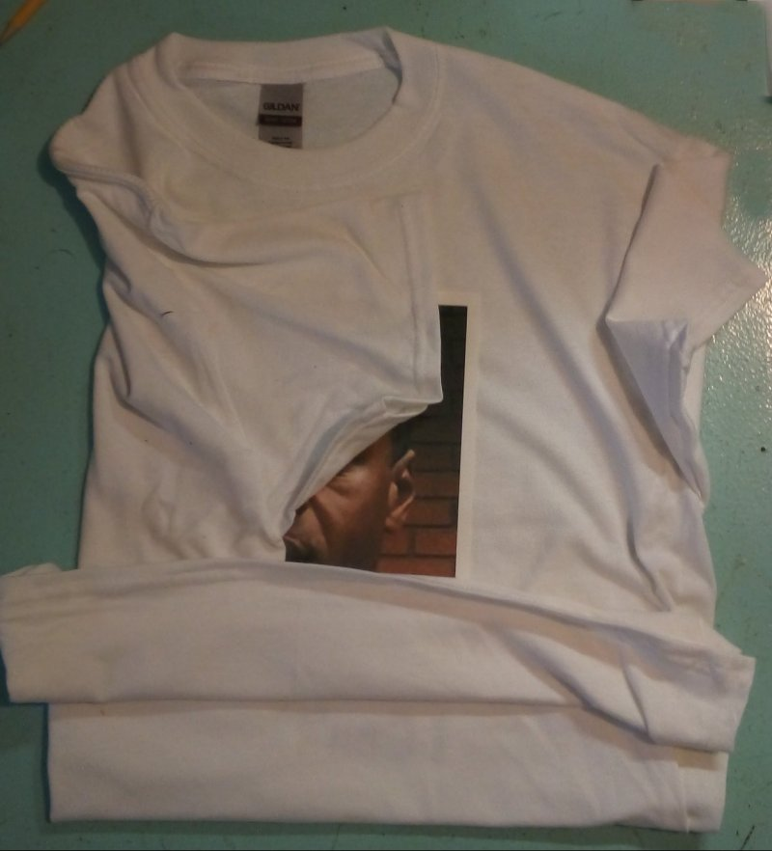

Fold in a way to keep image from crinkling. Fold as above, do not store in direct sunlight.
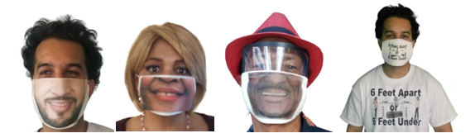
Smile and the whole world smiles with you

Mind VR.com 650 366 68102 3D VR, T Cinematic VR Films, Music Videos, Smile Mask covers.

